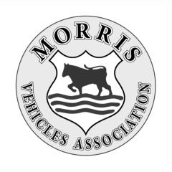
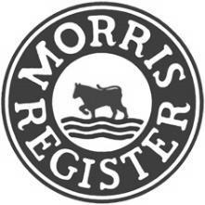
THE MORRIS REGISTER

NATIONAL RALLY
THORESBY PARK, NR OLLERTON, NOTTS, NG22 9EP
2nd to 4th AUGUST 2024
PLEASE COMPLETE IN BLOCK CAPITALS
Name Morris Register Membership No.
Address
 | Post Code
Telephone No. | Email

Class 1 – Morris Minors (Pre-war)
Class 2 – Morris 8 Tourers
Class 3 – Morris 8 Saloons
Class 4 – Morris 8 E Tourers/Saloons
Class 5 – Pre 1930 Over 8hp
Class 6 – Pre 1935 10/12hp (Inc 1935)
Class 7 – Post 1935 10/12hp
Class 8 – Post 1930 over 12hp
Class 9 – Morris Commercials
Class 10 – Post 1948 Morris Vehicles (Members only)
Class 11 – Any Classic Vehicle (Member or Guest)
Class 12 – Super Class (2023 class winners)
Class 14 – Vehicles under restoration
Registration No.
Year
Make
Model
Series
Type / Body Style
Class No. (see right)
If you do NOT want your vehicle to be judged please tick the box.
Please send the Friday night curry menu. Tick box
I want to take part in the Road Run. Tick box
I want to take part in the Gymkhana. Tick box
Yes | No

I agree to my name and vehicle details being published in the programme.
(The programme will be available to all rally attendees)
 | Entry per car or motorhome for the weekend (Including rally programme) |  |  | Number  of cars |  | £15
 | Camping per night - £10.00 Tents, Caravans & Motorhomes |  |  | Fri | Sat | Sun
 |  |  |  |  |  |  | £
 |  |  |  |  |  | Total | £
Payment |  | 
I have paid by Bank Transfer Tick box |  |  | Pre 1940 Morris Register Limited  Sort Code 30 – 92 - 86 Account Number 54993068
I have paid by PayPal. Tick box |  |  | PayPal is available through the Thoresby Rally page on the Morris Register website
 |  |  | . Cheques Can NOT be accepted.
Your Surname and Car registration, MUST be put in the payment reference box. We cannot match the payment to your entry without this information
Please email my rally pack and I will print at home
I enclose an A5 (Half the size of this sheet) STAMPED ADDRESSED ENVELOPE
Please return your completed entry form by
12th July 2024 to
Chris Powis. 11 Stacey Road,
Tonbridge, Kent. TN10 3AP
Or email to: tickets@morrisfest.co.uk
Declaration to be signed by all entrants
- I confirm that to the best of my belief the vehicle concerned is suitable for the use to which it will be put during the event and that the vehicle is roadworthy.
- I confirm that I and/or any other person(s) I may nominate to move, drive, control or operate the vehicle is/are competent to do so. - I confirm that the use of the vehicle hereby entered will be covered by insurance as required by law. I undertake not to allow anyone who is not insured to do so, to start, drive or otherwise operate the vehicle hereby entered during the course of the event. - In the event of any defect in the insurance referred to above, I undertake to indemnify the organisers in respect of any loss that would have been covered had the insurance not been defective.

SIGNED_____________________________________________DATE______________________________________

